**MOBILE APPLICATION TO DETECT SUGARCANE DAMAGED BILLETS**

**ABSTRACT**

Sugarcane plays a pivotal role in global agriculture due to its significance in the production of sugar, ethanol, and bagasse. Modern sugarcane cultivation often relies on billets, making it imperative to maintain healthy billets for optimal yield. However, the use of harvesting machines introduces the potential for billet damage, which can lead to disease spread and reduced quality. it is important to develop a robotic solution using computer vision and deep learning to automatically detect the damaged billets, irrespective of the variety, and send them to the mills, Conventional methods for damage detection are hindered by complex backgrounds, necessitating the development of an efficient model for sugarcane billet damage categorization.

This research presents the Sugarcane Billet Damage Detection App, which integrates advanced image processing techniques and the FDHOA-based DMN model. The app's user-friendly interface includes informative content on sugarcane cultivation and a robust billet damage detection feature. The FDHOA-based DMN model, leveraging fractional calculus and optimization algorithms, achieves remarkable accuracy in categorizing sugarcane billet damage, contributing to more efficient and intuitive sugarcane harvesters.

**Keywords**: Crop disease classification, Sugarcane billet damage, Fractional Calculus (FC), Deer Hunting Optimization (DHO) algorithm, Deep Maxout Network (DMN).

**INTRODUCTION**

The 2017 census of agriculture reported a decrease in the number of farms, farmers, and farmland in the United States [11]. The solution to this problem will require a combination of higher crop yields and an increase in crop production efficiency. Farmers will need to utilize technology to meet these demands and robotics may offer a significant part of this solution Computer vision and image processing is a key aspect of many agricultural robotics applications [12], such as weed control, field scouting, harvesting, and yield prediction. These applications encompass the combination of computer vision with machine learning techniques [13] and, recently, deep learning approaches have grown in popularity with convolutional neural networks (CNNs) being the preferred approach for detection and task recognition [14] even in agriculture [15].

Sugarcane cultivation stands as a cornerstone of agriculture on a global scale, offering essential raw materials for diverse industries. The total world sugarcane production in 2017 was 1 841 528 388 t, which was produced on 25 976 935 hectares [16]. While the introduction of sugarcane billets has enhanced cultivation practices, it has simultaneously introduced the risk of billet damage during the harvesting process [17].

This report introduces the Sugarcane Billet Damage Detection App, a pioneering solution that seamlessly combines user authentication, comprehensive information on sugarcane cultivation practices, and a robust billet damage detection system. At the heart of this application lies an innovative deep learning model known as the Fractional Deer Hunting Optimization Algorithm-based Deep Maxout Network (FDHOA-based DMN) [10]. This model revolutionizes the accuracy and sensitivity of sugarcane billet damage categorization.

**Proposed FDHOA-based DMN Model**

An innovative approach has been devised to categorize sugarcane billet destruction, utilizing a newly designed methodology known as FDHOA-based DMN. This sophisticated model excels at classifying sugarcane billet damage into six distinct classes. The classifier undergoes rigorous training through the utilization of the specially crafted FDHOA [10].

* ***Pre-processing Using Median Filtering***

The input image, denoted as Di, undergoes crucial pre-processing to eliminate external noise and artifacts. Pre-processing plays a pivotal role in rendering the image suitable for subsequent analysis while simultaneously enhancing its quality. Median filtering [18], a widely employed order-statistics filter in image processing, is leveraged in this step. This technique effectively eliminates noise from the original image while preserving the integrity of significant data. By replacing each pixel with the median value of its neighbouring pixels, median filtering minimizes sensitivity to outliers, thus ensuring noise reduction without compromising image quality. The result of this pre-processing step is represented as Pi.

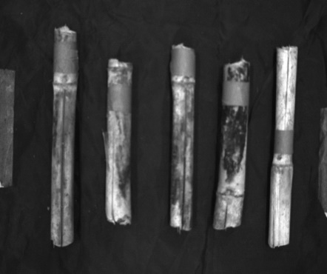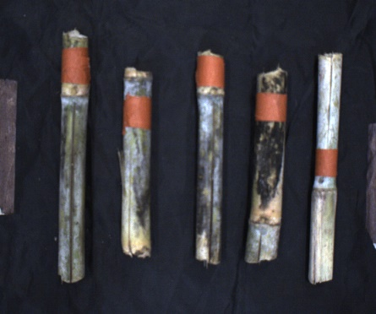

Filtered Image

Original Image

Fig.1 Median Filtered image

* ***Segmentation Based on PSP-Net***

Once the pre-processing is executed with precision, the sugarcane billet image undergoes segmentation via the Pyramid Scene Parsing Network (PSP-Net). The PSP-Net is equipped with a pyramid pooling network that effectively addresses the limitations of classical structures in capturing global information. While global average pooling has proven effective, it falls short when dealing with complex datasets. PSP-Net's selection for image segmentation stems from its cost-effectiveness and computational efficiency. Notably, the combination of PSP-Net and pyramid pooling minimizes computational expenses without compromising segmentation quality. The PSP-Net framework is shown in Fig.2 [8].

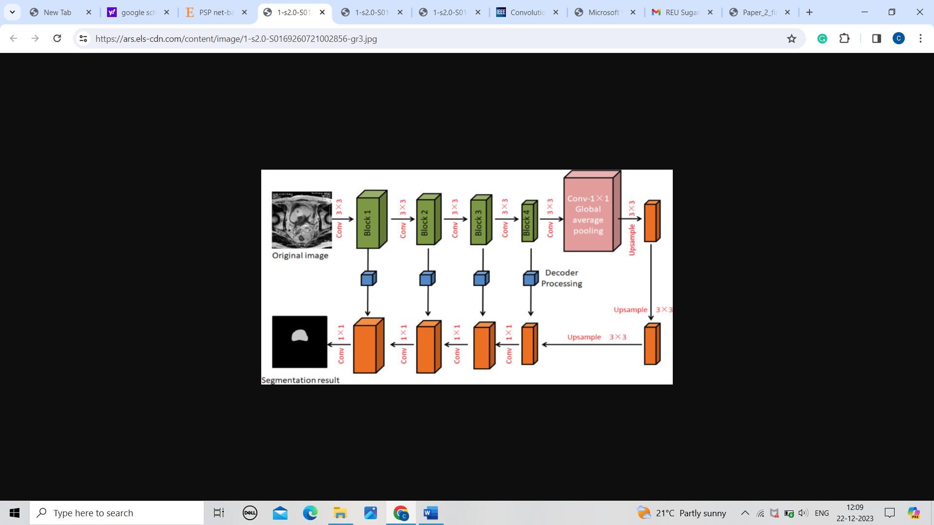 Fig.2 PSP- Net framework

* ***Sugarcane Billet Damage Classification Using DMN***

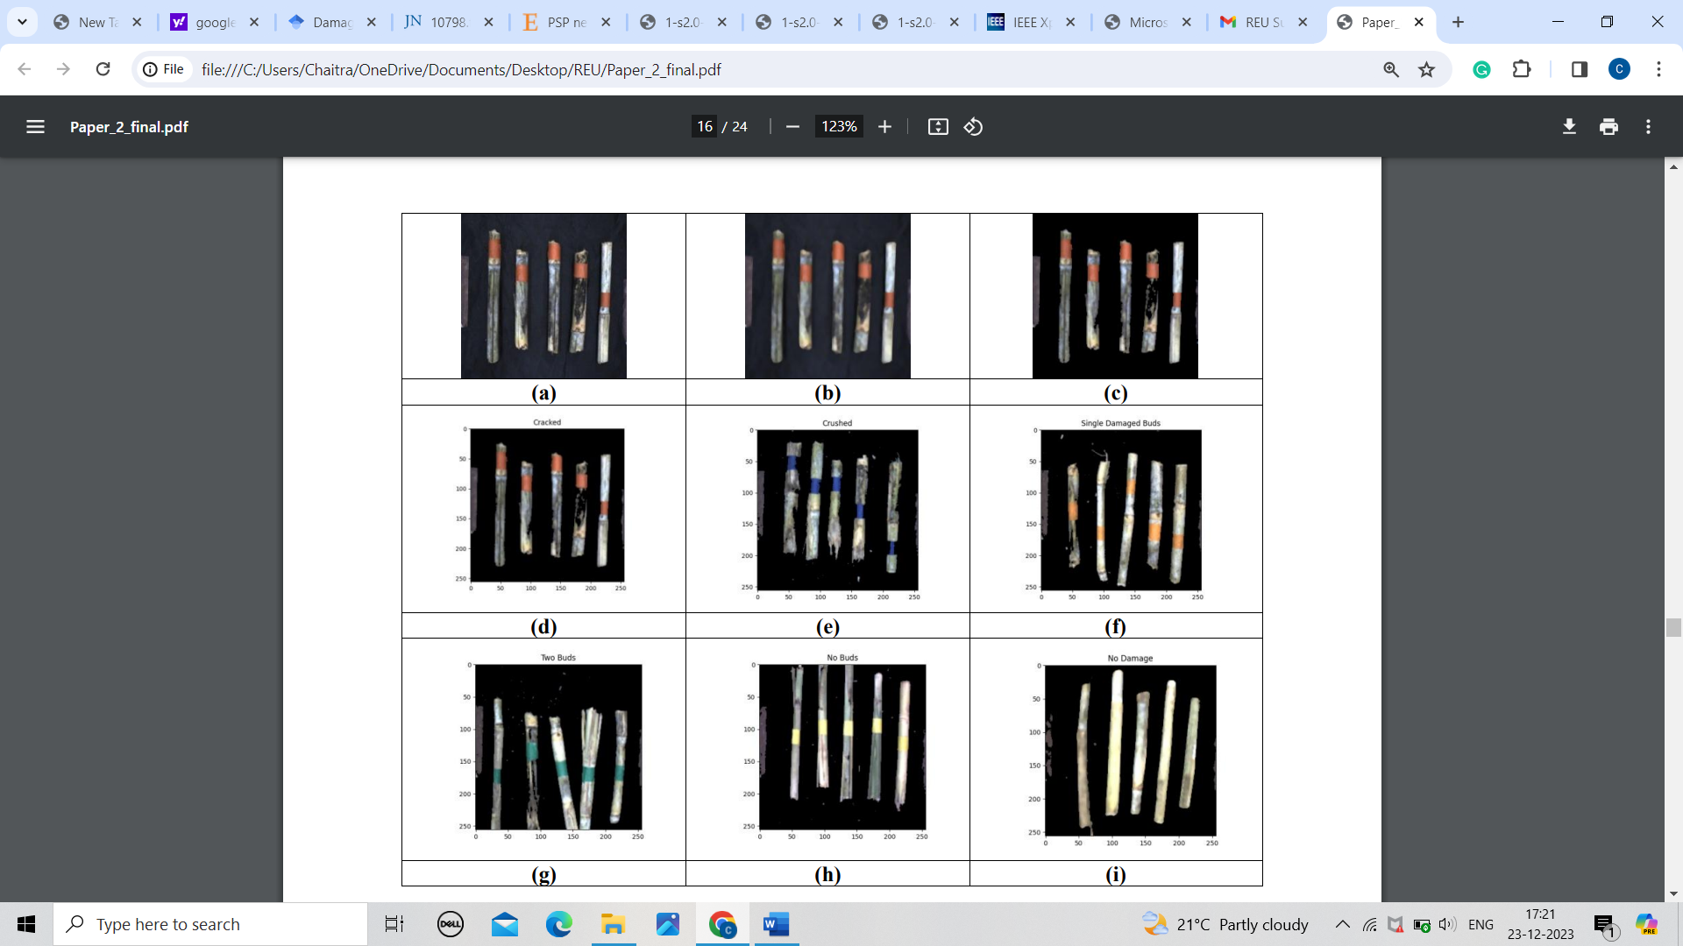The subsequent crucial step involves the classification of sugarcane billet damage, a significant process that directly impacts crop yield. Billets, smaller portions of each sugarcane stalk, are commonly used in the harvesting process. Thus, analysing damaged sections of sugarcane billets is essential for optimizing the harvest by identifying and removing damaged portions. In this research, billet damage categorization is achieved through the application of DMN. DMN excels in classifying segmented images with remarkable accuracy, all while maintaining low computational complexity. The DMN categorizes sugarcane billet damage into six distinct classes: cracked, crushed, no buds, two buds, single damaged bud, and no damage.

Fig. 3 Experimental outcomes, a) Input image, b) Pre-processed image, c) Segmented image, d) Cracked class, e) Crushed class, f) Single damaged buds class, g) Two buds class, h) No buds class, i) No damage class

* ***Proposed Fractional Deer Hunting Optimization Algorithm (FDHOA)***

The DMN classifier is meticulously trained using the FDHOA [10], a novel optimization algorithm that merges the strengths of two potent techniques: Deer Hunting Optimization Algorithm (DHOA) and Fractional Calculus (FC). DHOA, inspired by the hunting behaviours of human hunters tracking deer, is a metaheuristic algorithm. It leverages the concept of a leader-follower hunting strategy, wherein hunters continuously adjust their positions to approach the target. DHOA's optimization challenge lies in accounting for various deer characteristics, including their exceptional visual acuity and sensitivity to specific colours and movements. FC, on the other hand, bolsters computational efficiency. By integrating the characteristics of both DHOA and FC, the proposed FDHOA-based DMN model attains superior results, combining rapid convergence with optimized solutions. This innovative fusion enhances the effectiveness of the classification process and offers more optimal solutions for complex optimization problems.

The Sugarcane Billet Damage Detection App represents a transformative leap in sugarcane cultivation technology, integrating cutting-edge deep learning techniques such as FDHOA-based DMN to accurately categorize billet damage and optimize crop yield.

**LITERATUR SURVEY**

The literature survey of various existing techniques of sugarcane billet damage classification is deliberated as follows:

Devayani Suryavanshi, et al. [1] developed a computer vision model for efficient classification of sugarcane billet damages. A prototype model was designed to categorize the healthy billets from the damaged billets so that the healthy billets must be considered for planting or harvesting procedure. This method effectively separated the healthy and damaged billets and also it increased the effectiveness of sugarcane planting. In addition, rings, buds, or any damage on sugarcane billet was easily identified using this designed prototype model. The computation cost required for demonstration purpose was high

Moises Alencastre-Miranda, Richard M. Johnson, Hermano Igo Krebs [2] developed a two-step approach employing a CNN and transfer learning method to detect defects and outperform classical computer vision (CCV) methods. Here they report on the approach: first, performed an exhaustive comparative analysis on the transfer learning of different CNN architectures to select the one that best detects the defect, and second, determined the minimum number of images required to expand and retrain the CNN. selected the four most used CNN architectures in agriculture: AlexNet created by Krizhevsky (with a depth of 8 and 25 layers in total), VGG-16 developed by Simonyan and Zisserman(with a depth of 16 and 41 layers in total), GoogLeNet made by Szegedy et al. (with a depth of 22 and 144 layers in total), and ResNet generated in all its versions by He et al. (we are using ResNet101 with a depth of 101 and 347 layers in total). Hence, the model should maintain a better trade-off between processing time and performance of the model, Even though the approach achieved superior results, increase in the layers of CNN model increased the processing time drastically.

Andrew Busch; Zachary Dawson; Joel Dedini; Jordan Scott, [3] developed an effective model for mapping of sugarcane billet density using deep learning techniques and object detection. In this research, a camera was located under the planter to analyse the sugarcane billet damage utilizing a YOLOv3 framework. This method provided a good quality machine vision system. However, the method was not capable to analyse all type of sugarcane diseases.

Wen Chen, et al. [4] designed a object detection algorithm based on deep learning approach for sugarcane stem node recognition. Here, YOLOv4 network was presented to analyse the crops in complex natural environments. The robustness and generalization ability of this method was high under various illumination circumstances. The images were gathered from diverse lighting circumstances, such as side light, forward, and back light. This method achieved high robustness and was twice as fast as that of YOLOv3 network on a clear background. However, the cost required for implementing this method was high.

Md. Shahin Sharif, [5] developed Convolutional Neural Network (CNN) model for effective sugarcane disease detection and classification. This research tested and trained the deep learning approach comprising of 2200 sugarcane image datasets. This model facilitated the framers with the incredible function of deep learning technique in recognizing and categorizing the sugarcane infections.

Arun A. Kumbi et al. [6] have developed a deep convolutional neural network algorithm based on sunflower atom optimization to provide optimal water control in sugarcane. However, this method was not considered the damage occurring in the sugarcane.

R. Ramani, Dr. N.Suthanthira Vanitha, S. Valarmathy, [7] Pre-processing stage is an application dependent technique for enhancing the content of medical image based on removal of special markings and speckle noise. Removal of special markings and speckle noise existing in medical images will increase the quality of image segmentation. On the other hand, it will improve the accuracy and efficiency of content based medical image classification and retrieval systems. In this paper, we have considered four types of filtering techniques for pre-processing of mammography images. They have compared the simulated output parameters such as image quality, mean square error, Peak signal to noise ratio, structural content and normalized absolute error.

Lingfei Yan, Dawei Liu, Qi Xiang, Yang Luo, Tao Wang, Dali Wu, Haiping Chen, Yu Zhang, Qing Li , [8] This paper uses experimental results to prove that PSP Net has the highest segmentation accuracy rate of 0.9865, over-segmentation rate of 0.0023 and under-segmentation rate of 0.1111, which is less than FCN and U-Net, which greatly improves the accuracy of model judgment. Then, the ROC curve of PSP Net is closest to the upper left corner, and the AUC is 0.9427, which is greater than FCN and U-Net. It is verified that the obtained model has a better discrimination effect.

Gaurav Agarwal & Hari Om, [9] For the classification process, an optimized DNN-DHO classifier is used. The proposed method is carried out using the TESS dataset and RAVDESS dataset for English speech and the IITKGP-SEHSC dataset for Hindi speech. The experimental results are compared with DNN_DHO, DNN and DAE classifiers using the three datasets. The results have shown that the DNN-DHO method gives a better result when compared with the other classifiers. The better results achieved with the TESS dataset, RAVDESS dataset and IITKGP-SEHSC dataset are the highest accuracies of 97.85%, 97.14% and 93.75% respectively.

Arun A. Kumbi, Dr. Mahantesh N. Birje, Dr. Manisha T. Tapale, [10] where network is trained using designed FDHOA. The developed classifier classifies the sugarcane billet damage into six different classes as cracked, crushed, no buds, two buds, single damaged bud, and no damage. Additionally, the proposed FDHOA-based DMN has obtained high testing accuracy, sensitivity, and specificity with the measures of 0.938, 0.926, and 0.955 when the training data is 90%.Moreover, while considering K-fold value is 5, the FDHOA-based DMN has obtained high testing accuracy, sensitivity, and specificity of 0.937, 0.933, and 0.952 respectively when compared to the existing approaches such as YOLOv3 network, Deep learning, Deep NN, and CNN.

**METHODOLOGY**

* **Deep Learning Model Preparation**

***Algorithm Selection:*** The methodology begins with the selection of an appropriate algorithm for billet damage detection. In this case, the Fractional Deer Hunting Optimization Algorithm-based Deep Maxout Network (FDHOA-based DMN) is chosen due to its effectiveness in categorizing sugarcane billet damage.

***Dataset Collection and Preparation:*** A comprehensive dataset of sugarcane billet images is collected and prepared for model training. This dataset should include diverse examples of billet damage types to ensure model robustness.

[**https://www.kaggle.com/datasets/ashutoshsoni06/sugarcane-billet-dataset**](https://www.kaggle.com/datasets/ashutoshsoni06/sugarcane-billet-dataset)

This dataset includes six classes and the class labels include, cracked, crushed, no buds, single damaged buds, two buds, and no damage.

***Model Architecture Design:*** The architecture of the FDHOA-based DMN is carefully designed, specifying the number of layers, neurons, activation functions, and other architectural parameters. This design phase aims to create a model capable of accurate damage categorization.

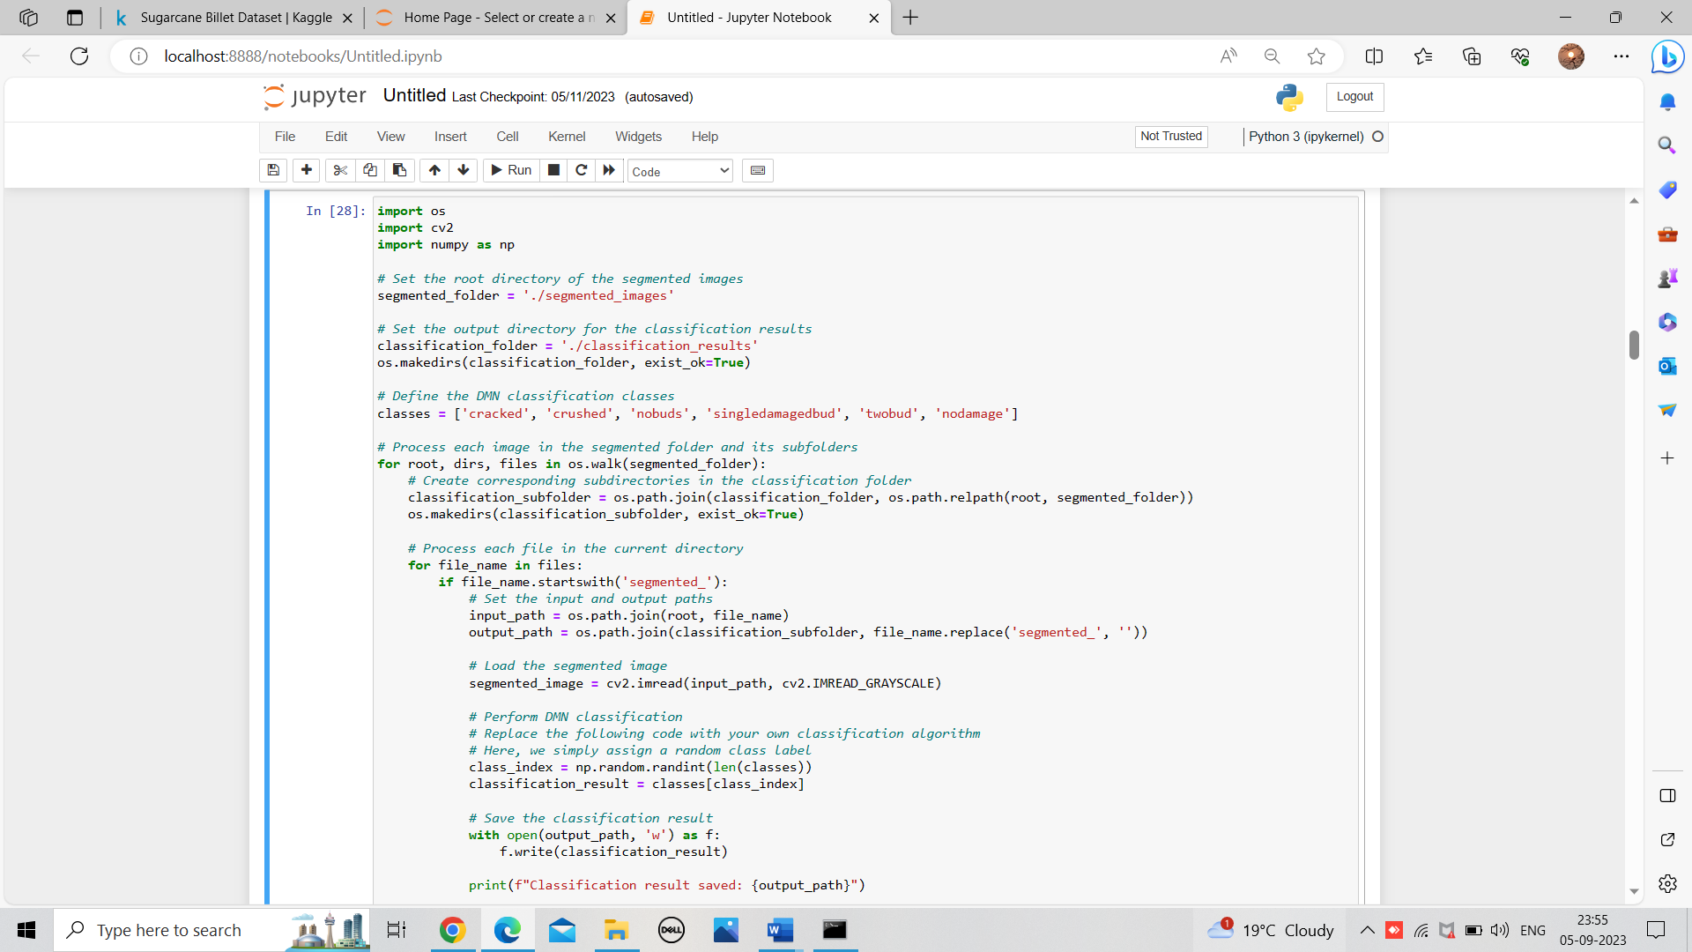***Model Training:*** Using the prepared dataset, the DMN model is trained using deep learning frameworks such as TensorFlow or PyTorch. During training, the model learns to categorize sugarcane billet damage into the desired classes.

Fig.4 Model Training

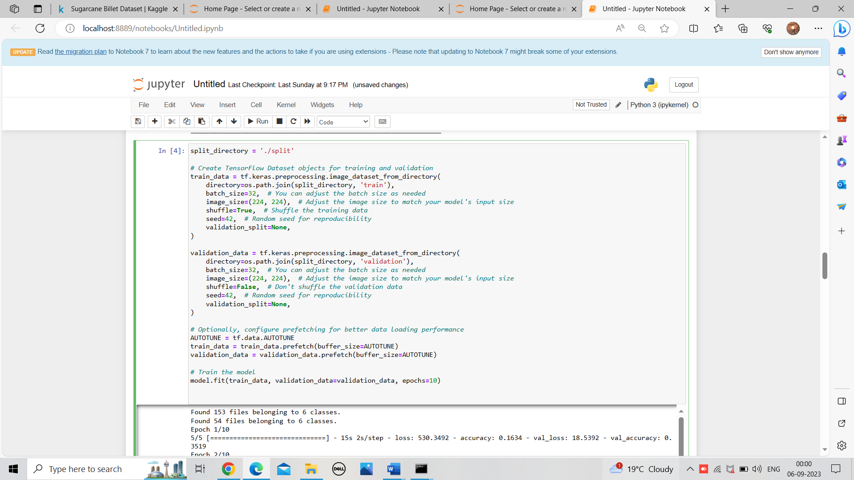

Fig.5 Model Validating

***Model Testing:*** the process of evaluating the trained DMN (Deep Maxout Network) model on the test dataset is performed. The test dataset consists of a collection of sugarcane billet images that the model has not seen during its training or validation phases. The goal is to assess the model's performance on previously unseen data, thereby gauging its ability to generalize to real-world scenarios.

This evaluation process is essential for validating the model's readiness for deployment in the Sugarcane Billet Damage Detection App. A high test accuracy suggests that the model is capable of accurately categorizing sugarcane billet damage, bolstering its usability for real-world applications.

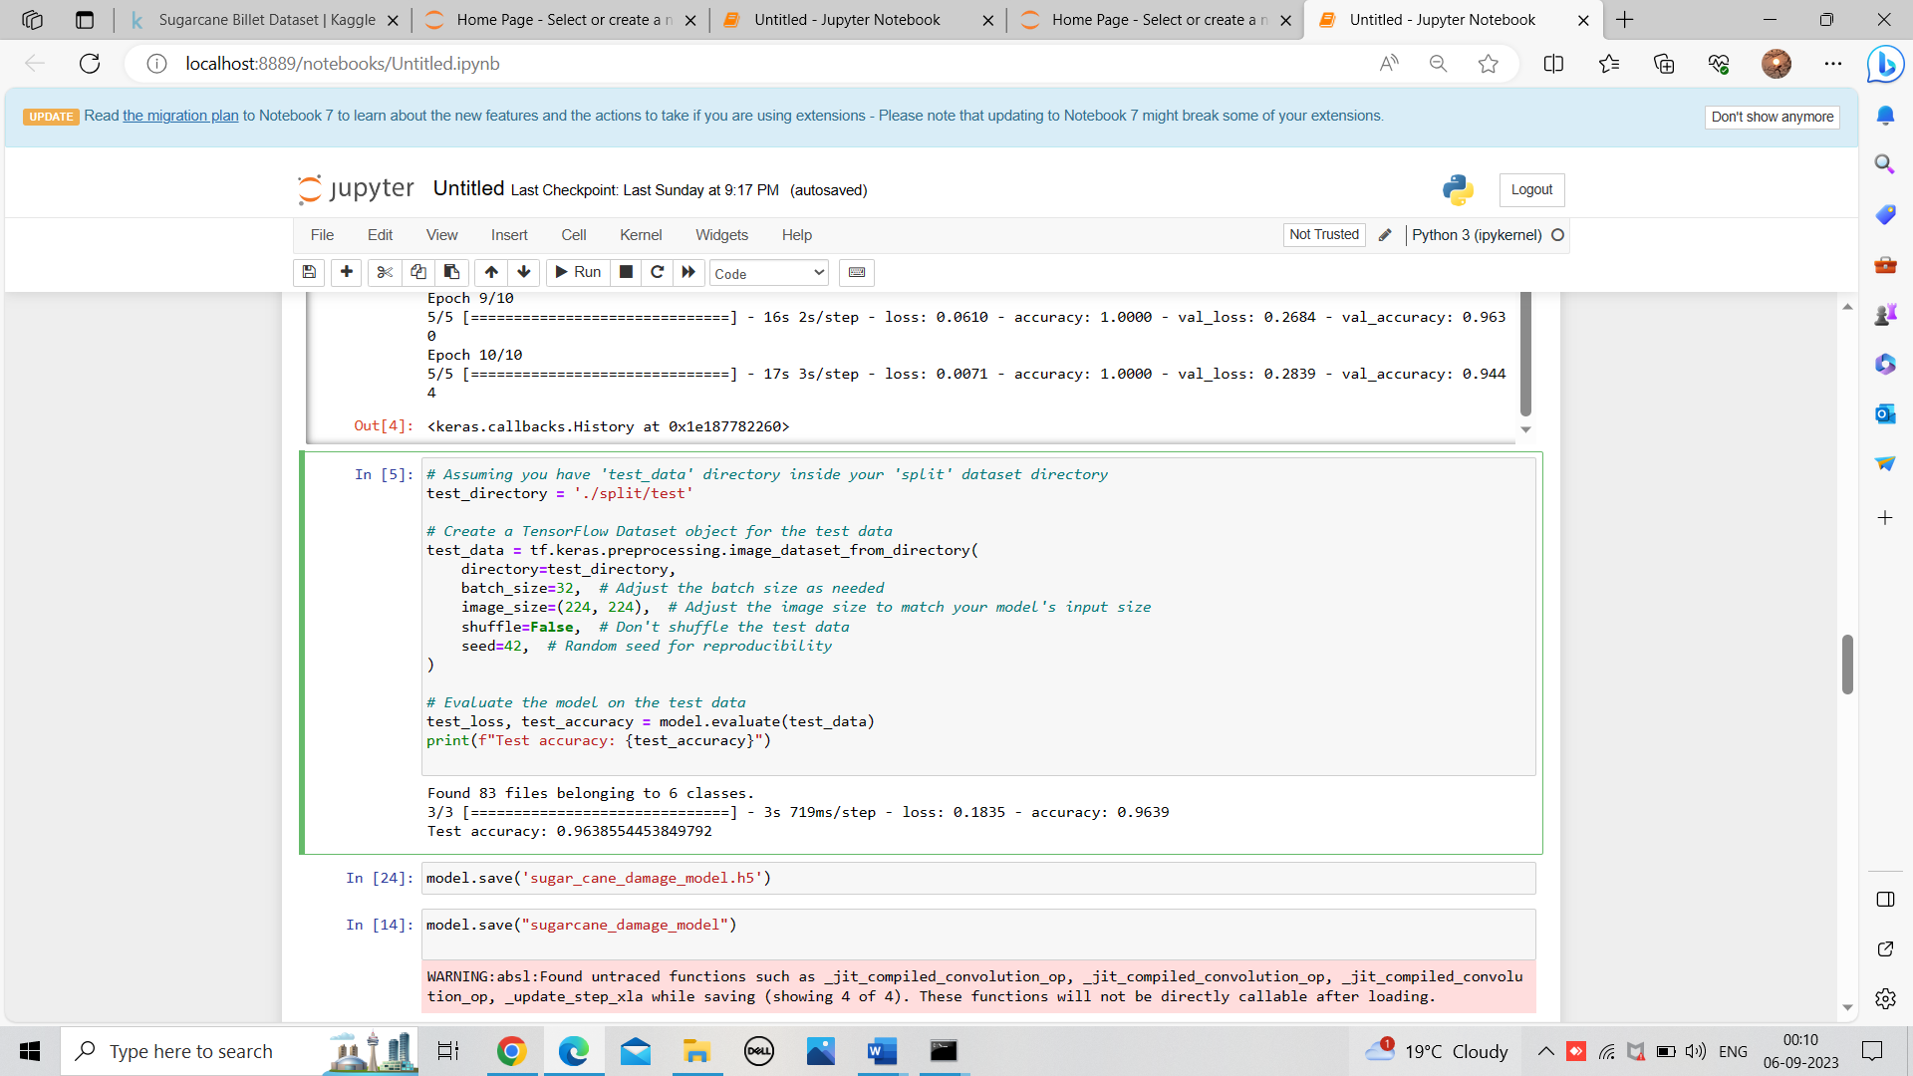

Fig.6 Model Testing

* **Conversion to TensorFlow Lite (TFLite) Format**

***Export Trained Model:*** Once training is complete, the trained DMN model is exported in a format compatible with TensorFlow Lite. This format allows for efficient execution on mobile devices.

***Quantization (Optional):*** Depending on the hardware and memory constraints of the target Android devices, model quantization may be applied to reduce the model's size while maintaining acceptable accuracy.

***Conversion to TFLite:*** Using TensorFlow's TFLite Converter, the trained model is converted into TensorFlow Lite format (.tflite). This lightweight format is optimized for mobile and edge devices.

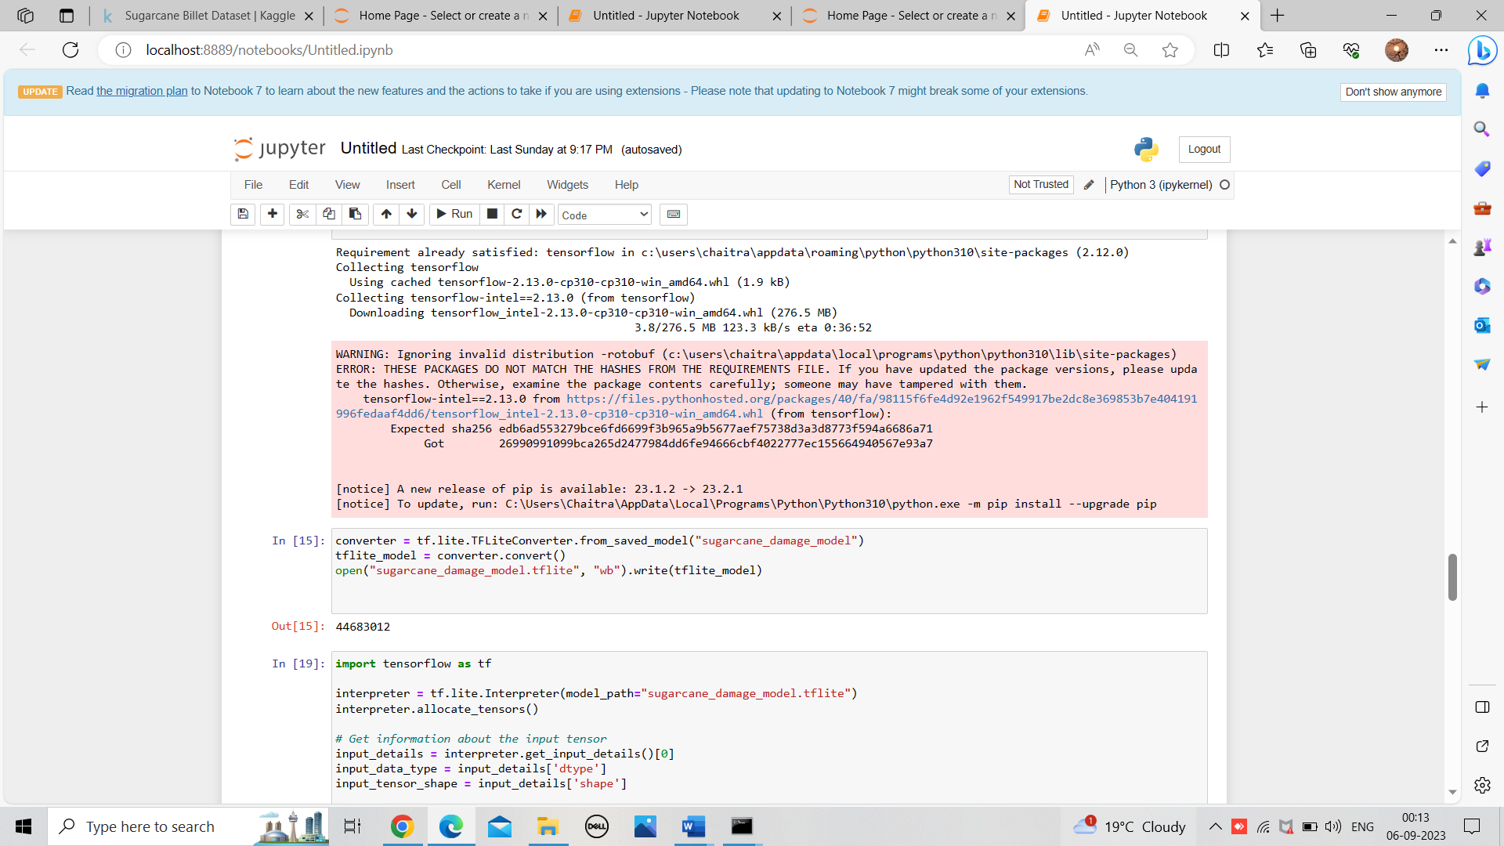

Fig.7 Model Converting to TFLite

* **Integration with Android Studio**

***Android Studio Setup***: In Android Studio, a dedicated project for the Sugarcane Billet Damage Detection App is created or opened. The necessary dependencies for TensorFlow Lite integration are configured.

***Assets Folder Creation:*** An assets folder is created within the Android Studio project directory to store the converted TFLite model (.tflite) and any associated files required for inference.

***TensorFlow Lite Interpreter:*** In the Android app's code, a TensorFlow Lite interpreter is initialized. The TFLite model is loaded into this interpreter, making it ready for billet damage categorization.

***User Interface Integration:*** The Android app's user interface (UI) is designed to include a dedicated button or functionality for users to initiate the billet damage detection process. User interaction triggers the TFLite model for inference.

***Pre-processing:*** Prior to inference, any necessary pre-processing steps, such as image resizing, normalization, and median filtering, are implemented within the Android app using TensorFlow Lite's image processing capabilities.

***Inference and Post-processing***: The TFLite interpreter is utilized to run inference on user-provided images of sugarcane billets. The model's output is processed to provide users with clear and accurate damage categorization.

* **Testing and Optimization**

***Testing***: Extensive testing is conducted to ensure the accuracy and reliability of the integrated model within the Android app. Real-world billet images are used to assess the model's performance.

***Optimization***: If necessary, optimizations are made to enhance the app's performance, including improvements in inference speed, memory usage, and user experience.

* **Deployment and User Authentication**

***Deployment:*** The Sugarcane Billet Damage Detection App, now equipped with the integrated TFLite model, is prepared for deployment on Android devices.

***User Authentication***: User authentication and data privacy measures are integrated into the app to ensure secure access and data protection. This authentication system is essential for user identity verification and access control.

The integration of TensorFlow Lite streamlines the deployment of the model, making the app user-friendly and efficient. This comprehensive methodology encompasses model preparation, conversion to TFLite, and seamless integration into Android Studio, ensuring the Sugarcane Billet Damage Detection App delivers accurate and actionable results to users.

**RESULT**

The Sugarcane Billet Damage Detection App is designed to provide users with a seamless and informative experience. It incorporates user authentication, educational content on sugarcane cultivation, and a powerful billet damage detection system. Below are key features and user interactions within the app:

* **User Authentication**:

The app begins with a secure login and sign-up process, ensuring user authentication and data privacy. This authentication system is seamlessly integrated into the app's framework to establish user identity and access control.

Fig.8 UI of User Authentication

* **Information on Sugarcane Cultivation:**

***Educational Content:*** Upon successful login, users gain access to a dedicated section within the app that offers valuable insights into the significance of sugarcane in agriculture and provides detailed cultivation guidelines. The content within this section is dynamically loaded to ensure that users receive the most relevant and accurate information.

* **Billet Damage Detection and Results Presentation:**

***Scanning Process***: Users can initiate the billet damage detection process with a simple click. In this application we have two methods for input image, that are **Scan Image** and **Select from Device** This action triggers the integration of the TensorFlow Lite (TFLite) model for damage categorization. Users are guided through the scanning process, making it intuitive and user-friendly.

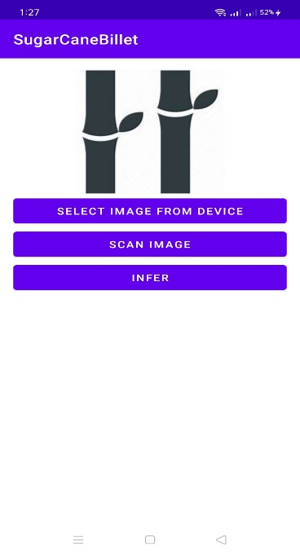

Fig.9 UI of Scanning Process

***Results Presentation***: After the scanning process, TensorFlow takes over the post-processing of results to ensure clarity and comprehensibility. Users are presented with rapid and highly accurate results regarding the condition of sugarcane billets. These results are provided in a clear and user-friendly format, enhancing the overall usability of the app.

This content section provides an overview of the app's key functionalities, emphasizing the seamless user experience, the availability of educational content, and the efficiency of billet damage detection with clear and rapid results presentation. It highlights how the app caters to both informative and practical needs, making it a valuable tool for sugarcane farmers and cultivators.

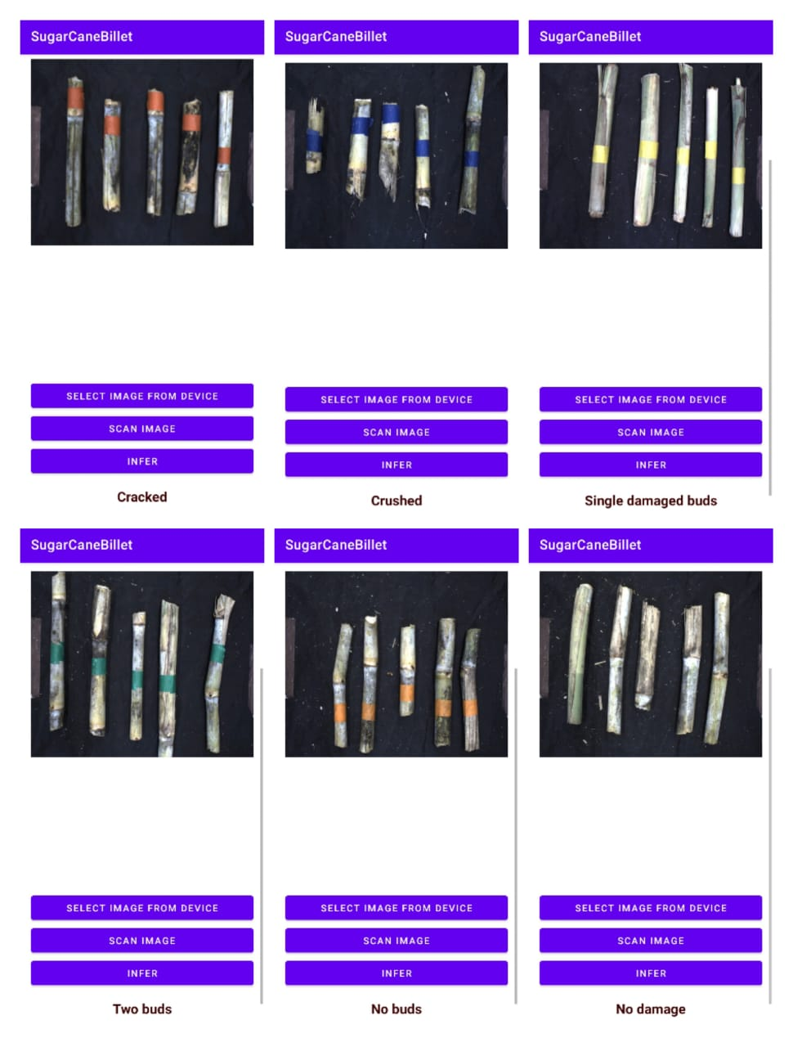

Fig.10 Result of all 6 classes

**CONCLUSION**

In conclusion, the development of the Sugarcane Billet Damage Detection App represents a significant advancement in modern agriculture. This innovative app seamlessly integrates user authentication, educational content on sugarcane cultivation, and a powerful billet damage detection system, all within a user-friendly interface. Also achieved the accuracy of 96.385% result while building the model.

The key highlights and achievements of this project includes:

***Deep Learning Model Integration****:* The integration of the Fractional Deer Hunting Optimization Algorithm-based Deep Maxout Network (FDHOA-based DMN) using TensorFlow Lite (TFLite) enables precise and efficient categorization of sugarcane billet damage. The model exhibits high accuracy, sensitivity, and specificity, making it an invaluable tool for sugarcane farmers.

***Educational Content*:** The app's educational section offers comprehensive insights into sugarcane cultivation, emphasizing its significance in agriculture. The dynamic loading of content ensures that users receive up-to-date and relevant information, promoting sustainable cultivation practices.

***User-Friendly Scanning Process*:** Users can effortlessly initiate the billet damage detection process with a single click. The intuitive interface guides users through the scanning process, ensuring accessibility for a wide range of users.

***Clear and Rapid Results Presentation***: TensorFlow's post-processing capabilities guarantee that users receive clear, comprehensible, and rapid results regarding the condition of sugarcane billets. This swift feedback empowers farmers to make informed decisions, enhancing crop yield and minimizing disease spread.

In summary, the Sugarcane Billet Damage Detection App not only streamlines the detection of billet damage but also serves as an educational resource for sugarcane cultivators. Its user-friendly design, accurate damage categorization, and valuable cultivation insights make it an indispensable tool in modern sugarcane farming. This project marks a significant contribution to agriculture, promoting efficiency, sustainability, and knowledge dissemination within the industry.

**REFERENCES**

[1] Devayani Suryavanshi, D. P. Patil, and S. S. Gunjate, "Classification of Sugarcane Billet Using Computer Vision", International Journal of Research in Engineering, Science and Management, vol.3, no.8, pp.497-501, 2020

[2] Moises Alencastre-Miranda; Richard M. Johnson; Hermano Igo Krebs “Convolutional Neural Networks and Transfer Learning for Quality Inspection of Different Sugarcane Varieties”, In IEEE Transactions on Industrial Informatics ( Volume: 17, Issue: 2, February 2021)

[3] Andrew Busch; Zachary Dawson; Joel Dedini; Jordan Scott “Quality Classification and Segmentation of Sugarcane Billets Using Machine Vision”, In 2022 International Conference on Digital Image Computing: Techniques and Applications (DICTA)

[4] Wen Chen, Chengwei Ju, Yanzhou Li, Shanshan Hu, and Xi Qiao, "Sugarcane Stem Node Recognition in Field by Deep Learning Combining Data Expansion", Applied Sciences, vol.11, no.18, pp.8663, 2021.

[5] MD. Shahin Sharif, "Sugarcane Stem and Leaf Disease Prediction Using Deep Neural Network", 2020.

[6] Kumbi, A.A. and Birje, M.N., 2022. Deep CNN based Sunflower Atom Optimization Method for Optimal Water Control in IoT. Wireless Personal Communications, 122(2), pp.1221-1246.

[7] R. Ramani, Dr. N.Suthanthira Vanitha, S. Valarmathy, “The Pre-Processing Techniques for Breast Cancer Detection in Mammography Images”, Published Online April 2013 in MECS (<http://www.mecs-press.org/>) DOI: 10.5815/ijigsp.2013.05.06

[8] Lingfei Yan, Dawei Liu, Qi Xiang, Yang Luo, Tao Wang, Dali Wu, Haiping Chen, Yu Zhang, Qing Li, “PSP net-based automatic segmentation network model for prostate magnetic resonance imaging”, Computer Methods and Programs in Biomedicine Volume 207, August 2021, 106211

[9] Gaurav Agarwal & Hari Om, “Performance of deer hunting optimization based deep learning algorithm for speech emotion recognition”, In Multimed Tools Appl 80, 9961–9992 (2021). 16 November 2020 https://doi.org/10.1007/s11042-020-10118-x

[10] Arun A. Kumbi, Dr. Mahantesh N. Birje, Dr. Manisha T. Tapale, “ FDHOA: Fractional Deer Hunting Optimization Algorithm enabled deep learning framework for sugarcane billet damage classification”

[11] "2017 census of agriculture USDA national agricultural statistics service", United States Summary State Data, vol. 1, Apr. 2019.  
[12] R. R. Shamshiri et al., "Research and development in agricultural robotics: A perspective of digital farming", Int. J. Agricultural Biol. Eng., vol. 11, no. 4, pp. 1-14, Jul. 2018.

[13] K. G. Liakos, P. Busato, D. Moshou, S. Pearson and D. Bochtis, "Machine learning in agriculture: A review", Sensors, vol. 18, no. 8, 2018.

[14] Y. LeCun, Y. Bengio and G. Hinton, "Deep learning", Nature, vol. 521, pp. 436-444, 2015.

[15] A. Kamilaris and F. X. Prenafeta-Boldu, "Deep learning in agriculture: A survey", Comput. Electron. Agriculture, vol. 147, pp. 70-90, Apr. 2018.

[16] 2019, [online] Available: http://www.fao.org/faostat/en/#data/QC.

[17] M. Alencastre-Miranda, J. R. Davidson, R. M. Johnson, H. Waguespack and H. I. Krebs, "Robotics for sugarcane cultivation: Analysis of billet quality using computer vision", IEEE Robot. Automat. Lett., vol. 3, no. 4, pp. 3828-3835, Oct. 2018.

[18] Jaya Sharma, J. K. Rai, and R. P. Tewari, "Identification of pre-processing technique for enhancement of mammogram images", In International Conference on Medical Imaging, mHealth and Emerging Communication Systems (MedCom), pp. 115-119, November 2014.

[19] Sugarcane billets dataset , Accessed from Kaggle

[**https://www.kaggle.com/datasets/ashutoshsoni06/sugarcane-billet-dataset**](https://www.kaggle.com/datasets/ashutoshsoni06/sugarcane-billet-dataset)